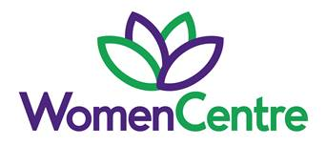
Domestic Abuse Practitioner (DAP)

Hours: 35 hours per week
Salary: £27,344 to £29,439 (Pro Rota: £25,862.20-£27,846)
Contract: 31st March 2031
Based at: WomenCentre, Huddersfield

WomenCentre are pleased to offer an exciting opportunity for a domestic abuse practitioner (DAP) as part of the Kirklees Better Outcomes Partnership (KBOP).

Primary Objectives/Main purpose of the Role:
To work within a skilled team providing high quality frontline specialist support services to victims of domestic abuse. The DAP team work with victims of domestic abuse aged 16+ living across Kirklees through an advocacy, support and outcomes based framework. To establish and maintain positive, proactive and innovative working relationships, pathways and referral routes with partner agencies to reduce barriers arising for victims of domestic abuse reaching out for support.

We are an organisation that promotes safeguarding practice across all our service delivery, staff and volunteer recruitment. Appointment is subject to a satisfactory DBS check.

Closing Date: 9.00am Monday 18th May 2026
Interview Date: Wednesday 27th May & Thursday 28th May 2026

For an informal discussion please contact Carley Cowburn carley.cowburn@womencentre.org.uk

Application packs are available on our website: www.womencentre.org.uk

Company number: 06084795 Charity number: 1118366

