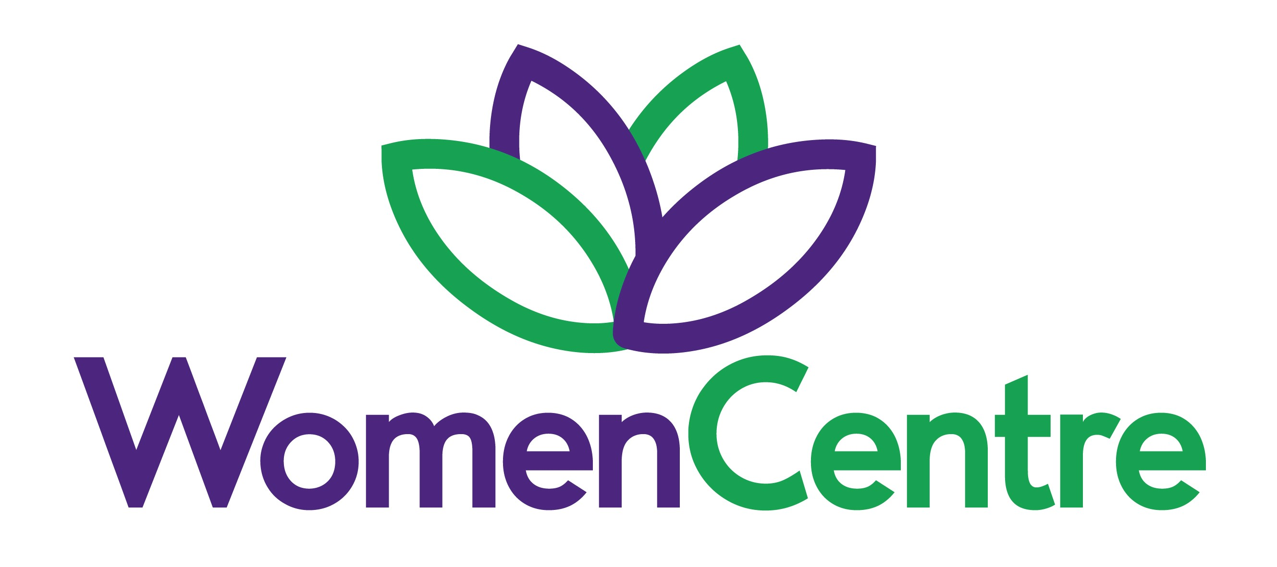

Sessional Group Facilitator
Scale SO1 £15.67 to £16.64 per hour
(£18.28 to £19.42 per hour inc rolled up holiday pay at 10 min per hour worked)
5 hours per week in term time
Currently funded until 31st March 2028

The post holder will facilitate and deliver two weekly groups, which will run for 5/6 weeks in term time only. There may be an opportunity to deliver more groupwork if additional funding is made available

The ideal candidate will have a relevant counselling qualification, group delivery experience and some clinical experience of assessing and counselling women. You will be supporting women who have multiple and complex issues and vulnerabilities and need to have the ability to recognise potential risk and take appropriate action, when required.

Application deadline: 9am 7th September 2026
Shortlisting: 7th and 8th September 2026
Interviews: 15th September 2026

If you would like to find out more about the roles, please contact Jane Ashworth 07485 304326 or Lynn Walsh 07540 635712

For more information about the above posts and to download an application pack please visit our website: www.womencentre.org.uk.

All applications to be returned to: HR@womencentre.org.uk

This post is open to women only – Equality Act 2010, Schedule 9, Part 1 applies

WomenCentre promotes safeguarding practice across all our service delivery and staff and volunteers.

www.womencentre.org.uk

Registered Charity Number: 1118366 Company Number: 6084795

